OLA / Memberclicks
Login & Landing Page

Oregon Library Association uses Memberclicks for its all-in-one membership management software. It offers everything that small-staff associations need to make the most of the web, with database, web, event registration, calendaring, etc.

Your username and password will work on either the standard or administration login pages. Using the standard login page will give you access to your membership profile, listservs you have signed up for or can sign up for, conduct a membership search….

1. Standard login page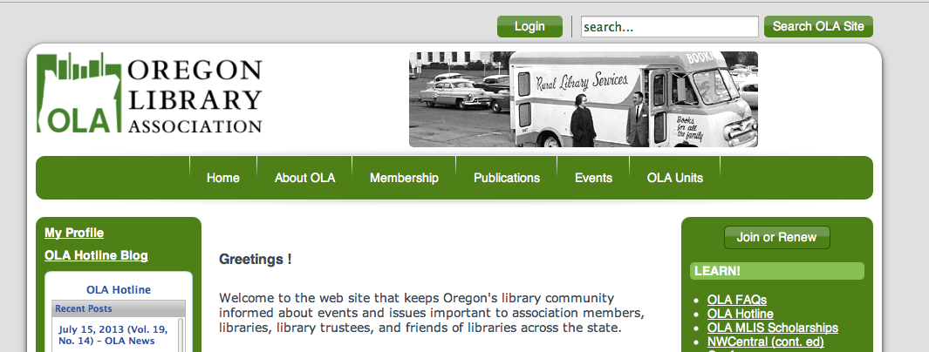

2. The standard landing page you will see

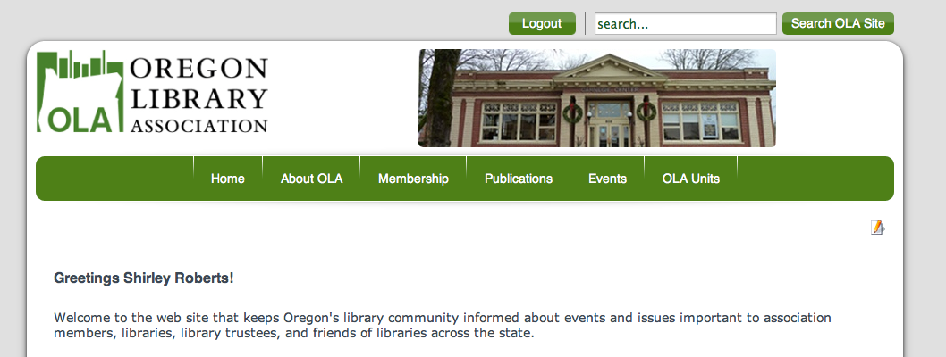

The administrative login page will give you access to more functionality. You will be able to upload documents, edit web pages, create and/or edit forms……

3. Administrative login page https://ola.memberclicks.net/administrator/?servid=2863
Again use the same username and password you used for the standard login above.

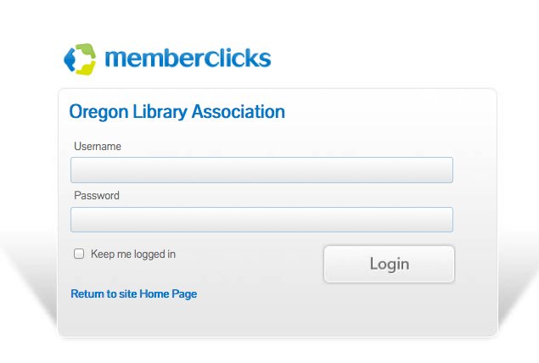

4. Administrative landing page
